Design for NRIC mobile application

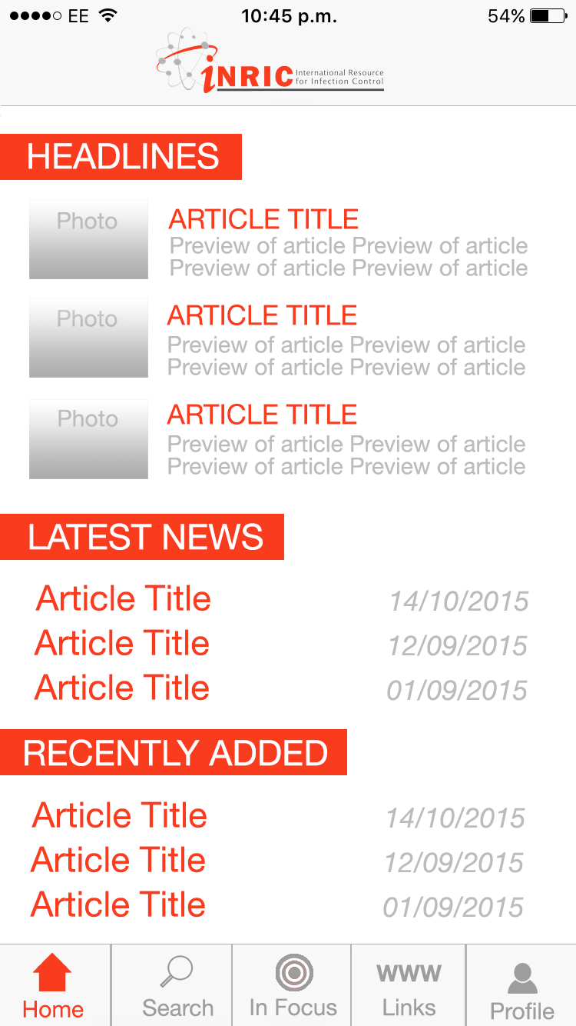Mock-up of Home screen on iOS (Android will look similar)

The application view is obviously dependent on the screen size and resolution, but almost all screen sizes will support 5 buttons on the main application menu.

**Home** -> Will be the mobile version of the desktop home. Clicking on the “Latest News” headline will take the user to the News page.

**Search** -> will be a page that will contain the Resource search function as well as the ability to search within News. A button to “Contribute” will also be here after the search results are shown

**In Focus** -> This button will link to the “International Infection Prevention Week” page. It will also be merged with the “Training” page

**Links** -> This button will hold the combined pages of “Conferences” and “Directory”

**Profile** -> Will contain user profile settings and About page

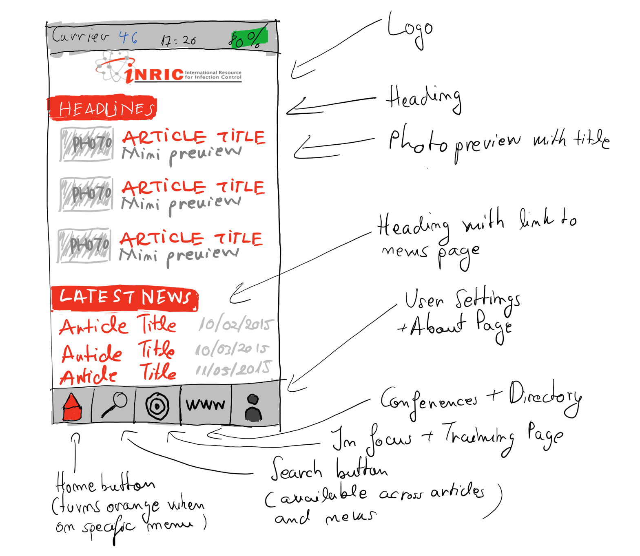

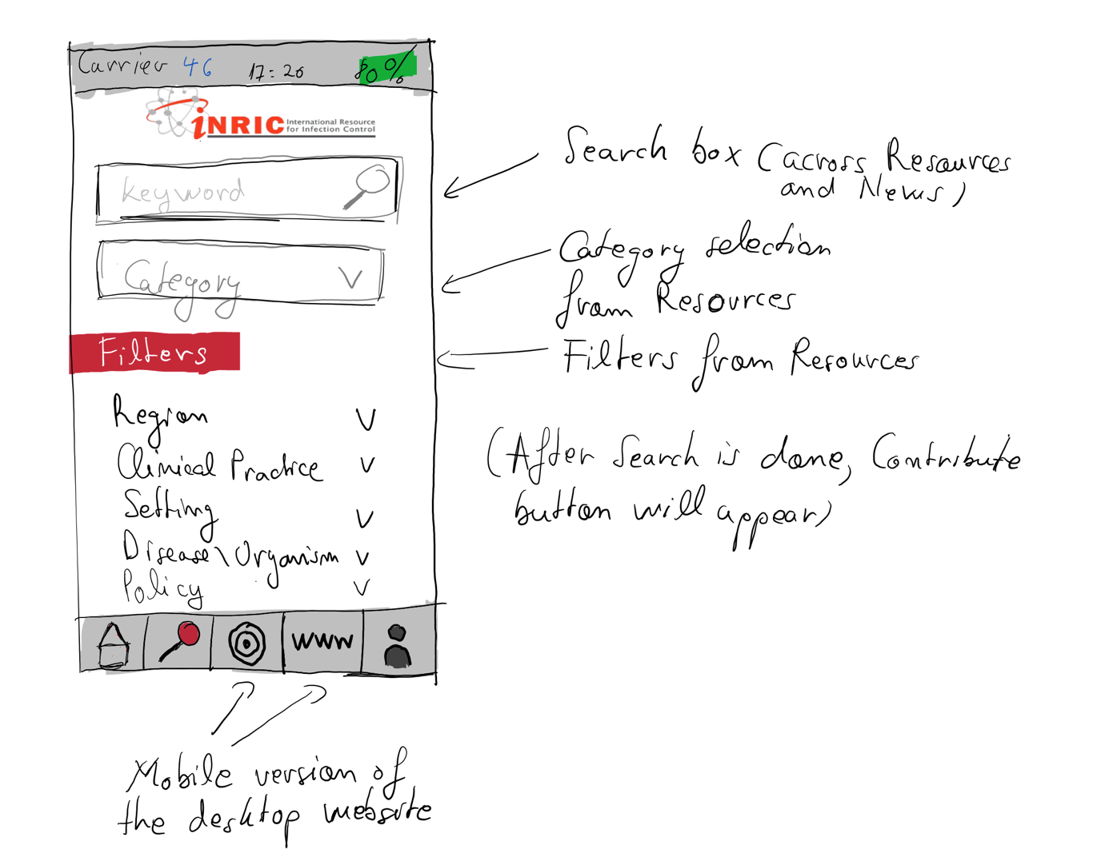

# User Profile

**Photo:** (Optional)

**Username:** (Should be email)

**Password:** (On setup – Link to change if forgotten)

**Email:** (Will be sent confirmation email before registering to avoid spam)

**Country:** (Important when showing headlines and articles)

**Institution:** (Optional)

**Phone No.:** (Useful in case of forgotten password, but not necessary)

**Article Categories:** (User chooses the categories they are interested in either on the mobile app or on the website, thus influencing the article notifications, headlines and news they receive)